Style File
Fall/Winter 2009/10

FALL FASHION TAKES OFF!
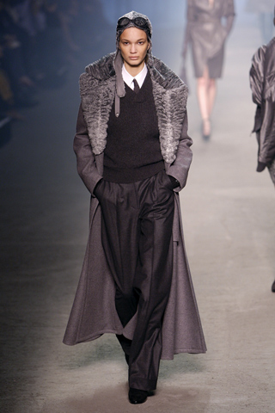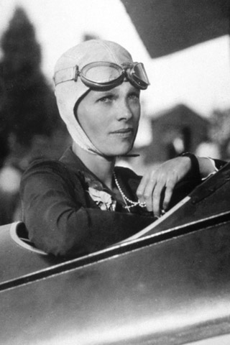
It seems as though Fall has just begun and there’s a chill in the air already! And not just the crisp fall air, we’re talking December-like chills. I was hoping to stretch my summer wardrobe-perhaps into the next few weeks, but my attempts were futile-as the temps in NYC have plunged considerably. Pretty soon we will be shrouded in our Winter Coats & warm layers–only to emerge in Spring(that is if we have a Spring this year! ) Fashion is taking off this Fall! And, if anyone doubts that history, cinema and real life heroes dictate fashion trends, just look at the above photos depicting the similarities between this season’s runway and Aviation legend Amelia Earhart. Earhart disappeared while boldly trying to fly across the Atlantic in 1937. Though actress Hilary Swank just played the pioneering aviator in the recent flick “Amelia” –the real life Earhart created her own flight of fashion over 70 years ago. While this look did not dominate the runways of Fall ’09, it certainly has a hand in the very recent tough-chic look of our times.
So, without further adieu-here goes my take on Fall Winter Dressing for 2009/10. But before we delve into the trends of the season-I must alert you to the accessories story coming up below, where I will have tips and trends from noted Jewelry trend expert and former fashion PR maven; Jennifer Gandia. Jennifer is a former PR manager for NARS cosmetics…and she’s also honed her fashion PR skills with the likes of fashion Icons; Alexander McQueen, Todd Oldham, Badgley Mischka and brands such as Diesel and BCBG to name a few. So read on for must-have jewelry & accessorizing advice!
What to Rock and what to Roll?...is the question that is answered by one of this season’s top trends: Biker Babes! The tough chic look is back with a vengeance. Designers are showing everything from cropped leather biker jackets to zippers galore on strong-shouldered leather looks. A couple of my faves were shown at Balmain & Rag & Bone. (pictured below-photos courtesy: Balmain, Rag & Bone)
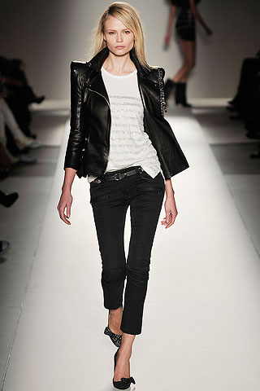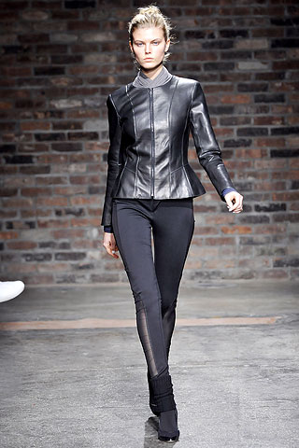

The way to pull off the tough-chic trend is to pair one of these Biker jackets with a feminine Frock-such as a frilly evening dress or flirty mini. For a more casual day look you can try pairing it with your favorite pair of jeans or cropped pants. Either way, make sure you add just a touch of sweetness to soften this sometimes serious look.

MUST-HAVE ELEMENTS of THE SEASON:
In addition to the biker jacket-there are some other must-haves to work into your wardrobe for this season. Try the Boyfriend Jacket with Boyfriend Tee, Delve into Distressed Denim, Pick up some casual Plaid shirts. As for shoes…look for ruffles adorning t-strap sandals and booties, Ride the western wave with cowboy boots and go sexy with the season’s must have :over-the-knee boots, but be warned…you must have some pretty long legs to stand on in order to rock these boots! And don’t forget the ever present leggings and stockings in color & in wild prints.
Go Knee High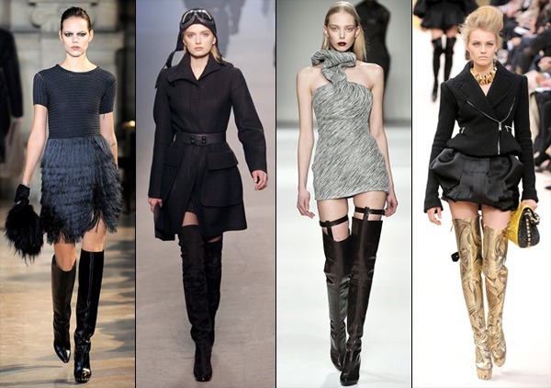

80’s Redux:
It seems the era of sharp shoulder pads and club like get-ups for day just won’t go away. I have to say I was not too pleased when I heard of an 80’s remix gracing the catwalks for Fall, but some designers did it right. As seen here in above photos courtesy of Gucci and Balmain, 80’s Glam is back.
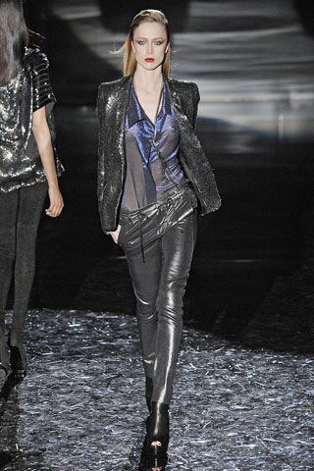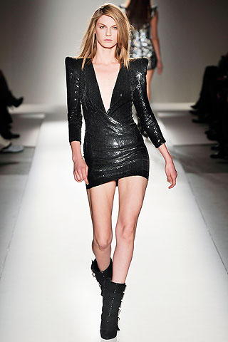80’s are back once again!

SMART DRESSING
Even though reports say we are headed out of this recession-the mere fact that we were plunged into such financial turmoil-had most Fashionista’s turning into Recessionistas, forcing many to cut back and Invest in smart classics. Evidence of this attitude was all over the fall runways with classics such as the Trench, Little Black Dress(LBD), and mixing menswear with metallic for a versatile day–to- night look. (as shown here below)

The Trench, LBD & Menswear Classics
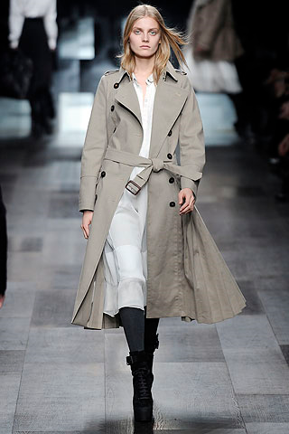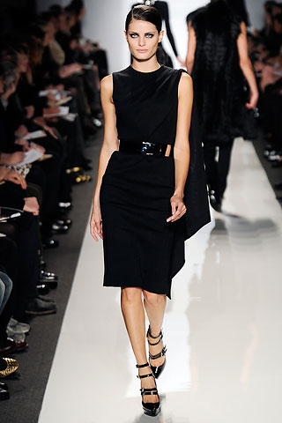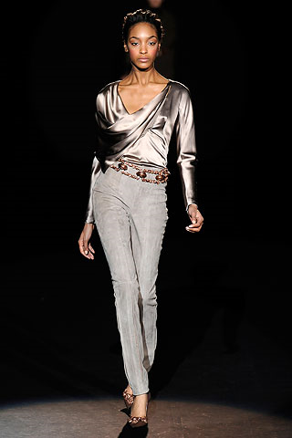

Bejeweled, Bedazzled & Best Dressed!
No matter how well-informed we are about the current fashion trends, there’s always more to know about how to make an oufit really pop! And it doesn’t hurt to know how not to commit a fashion faux pas by ruining an otherwise great ensemble with the wrong accessories. We recently spoke with jewelry trend expert; Jennifer Gandia of Greenwich Jewelers in Lower Manhattan.

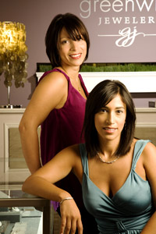 Jennifer(pictured left with her sister Christina Gandia Gambale ) is the daughter of a Jeweler, but her real passion was for fashion. She was reading Vogue Magazine at 13 years-old, went to FIT in New York City and worked in fashion PR for fashion icons Alexander McQueen, Badgley Mishka and well-known brands like Diesel and BCBG. She credits Francois Nars as being one of her greatest mentors-and she served as PR manager for Nars Cosmetics for many years.
After the events of 9/11, she began to reflect on her life and career and thought; “ while PR is fun it’s not very fulfilling”…and decided to take some time off to help her parents with their store, which was seriously affected by the attack. After helping her parents with re-decorating their store and helping with some marketing –she decided to go on another hiatus. She lived in Barcelona for a year, and it was there she found herself awed by the architecture and beauty of the city, but-oddly enough- often gravitated towards Jewelry store windows. She then returned to New York, after some serious soul searching & decided that jewelry was her true calling and says “It’s funny how sometimes you have to go far away to realize that what you are looking for is right under your nose.”
The Statement Necklace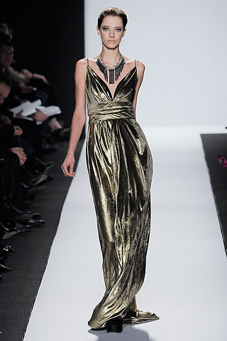…. 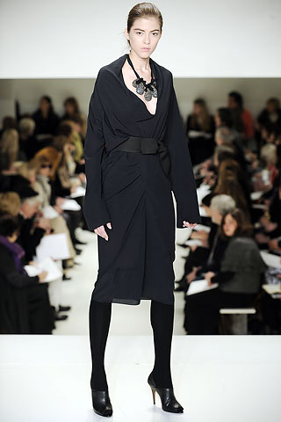

Style File: Jennifer-What trends are we seeing in Jewelry for Fall/Winter ’09?

JG: There are a few major trends happening this season. First, is chain – silver, gold, mixed metals & links – chain is everywhere. You can wear a single long or chunky link or drape yourself in different lengths. There’s this tough girl thing happening in fashion right now so you may wear a LBD but it should be with a chain necklace or bracelet and studded heels!

- Statement necklaces – there are loads of chunky necklaces, from very edgy to more feminine styles but they all have one thing in common – Presence. There’s lots of versatility within this trend which is great and allows every woman to find something that will add WOW to her look effortlessly.

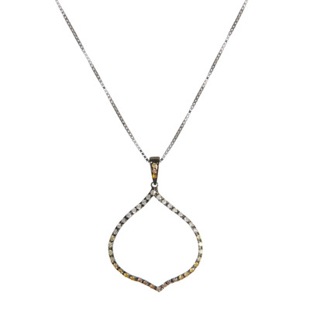 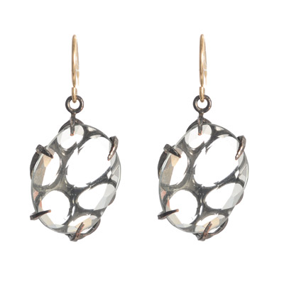Black & White

- Black & white – Black diamonds in white metals, blackened metals with brilliant gemstones – this jewelry trend enhances the ladylike designs we are seeing with an edgy quality. It’s like saying “Don’t f*ck with me, I’m a lady”, if you know what I mean…

SF: What is your personal favorite(in terms of jewelry looks this season)
JG: You should know that you are talking to a Pisces which means my favorite piece changes on a daily basis. It all depends on how I wake up and what my “look” for the day is going to be. I have been wearing a silver link necklace by Claudia Lobao for a few months now and I haven’t tired of it yet so perhaps that is my favorite piece! I am definitely loving all the necklaces right now. It’s a necklace moment.

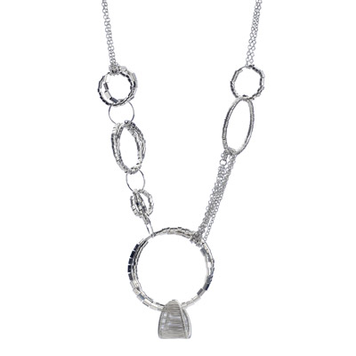A Claudia Lobao creation

SF: With the recession still on-what advice can you give to those who want to invest in one piece of jewelry This Year. ?
Jg: I think there are two answers to this question. If you are the kind of person who wants a must-have item I would have to say a statement necklace. With the right one you can go out in NYC with a white t-shirt, black jeans and a killer necklace and you are DONE. You can take that same necklace and wear it over a black sheath dress & voila! – you are officially the best dressed woman in the room, and that can be a board room, dining room, where ever. That is the power of good accessories.

SF:How do you go about finding new Jewelry design talent?
JG: I go to trade shows, read magazines, blogs, internet , I look at women on the street. I am not above asking someone where the fabulous piece she is wearing comes from. Our store caters to all kinds of women so I strive to have designers that have very different points of view and price points. My father never wanted to turn someone away, and that is not to say he didn’t want to lose a sale, he wanted everyone who walked through the doors at Greenwich Jewelers to be able to leave with something special. He felt it was an honor to serve the people who came through his doors. I absolutely feel the same way and I’m always looking for great design and quality at all price points. It must look and feel special whether its $50 or $5000.
SF: What is the biggest mistake women make when wearing jewelry?
JG: I think the biggest mistake you can make is not taking chances. Jewelry is meant to delight you! It should be a talisman that when worm makes you feel MORE – your beauty and feminine power should be enhanced! If you are wearing the same styles and pieces over and over for many years you must shake it up a bit. Find something that speaks to you whether it be from a street vendor, antique shop or a great jewelry store and treat yourself. Trust me, it’s money well spent!

Thanks Jen! For more information go to: GreenwichJewelers.com

